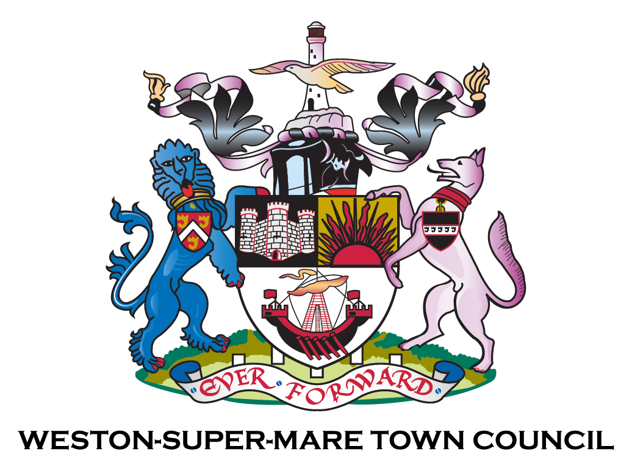

Devolution Programme Framework –
February 2026

Documents incorporated into the Weston-super-Mare Town Council Devolution Framework
Document | Date | Author | Origin of change e.g. change in legislation etc. | Received from / Recommended for inclusion by:
Local Devolution Programme: A Framework for Asset and Service Transfer in North Somerset | November 2025 – Version 2 | North Somerset Council | Local authority asset and service devolution | Received by Devolution S&FG – January 2026
Summary of Devolution S&FG asset transfer recommendations – Devolution Programme | January 2026 | Devolution Programme Manager (SJ) | Commencement of WsMTC Devolution programming | Received by Devolution S&FG – January 2026
WsMTC Devolution Principles | January 2026 | Town Clerk (SP)/ Devolution Programme Manager (SJ) | Local authority asset and service devolution | Received by Devolution S&FG – January 2026
Community Outcomes Framework | - | Community Resilience team | - | Received by Devolution S&FG – January 2026

Author: | Devolution Programme Manager
Date adopted: | 16th February 2026
Approved by: | Finance & General Purposes Committee

Contents
1. Introduction 4
2. Why a Devolution Framework is needed 4
3. Strategic Context 5
3.1 Alignment with the North Somerset Council Devolution Framework 5
3.2 Alignment with the Town Council Strategy 5
4. NSC Devolution Framework – Summary of key elements 5
4.1 Purpose and Objectives of the NSC Framework 5
4.2 Potential Outcomes of Devolution – Delivery Pathways 6
4.3 NSC Devolution Principles 6
4.4 NSC Criteria for Assessing Devolution Proposals 6
5. WsMTC Devolution programme - Governance and Oversight 7
5.1 Devolution Start & Finish Group 7
6. Devolution Principles 8
6.1. Devolution Principles variation 9
6.2 Principle variation for the devolution of Play Areas – January 2026 10
7. Assessment considerations for Devolution proposals 10
7.1. Devolution proposal checks 10
7.2 Other Devolution proposal assessment criteria 11
7.2.1. Community Outcome Framework 11
7.2.2. WsMTC Policies 12
7.3. NSC and WSMTC alignment of proposal assessment guidelines 12
7.4 Assessment of implications, equality and community impact 12
7.4.1 Financial, Legal and Risk Implications 12
7.4.2 Equality and Community Impact 12
APPENDICES 13
Appendix A - Calendar of meeting dates for the Groups and Committees relevant to the Devolution programme 13
Appendix A1: Summary of the Devolution S&FG meetings and meeting outputs and recommendations 14
Appendix A2: Emerging WsMTC Devolution Programme of work 15
Appendix B: Devolution Principles variation log 16
Appendix C: WsMTC Strategic Priorities 2020 – 2030 – The Five Pillars 16
Appendix D: Community Outcomes Framework 17
Appendix E: Key WsMTC policies to support assessment of suitability of Devolution proposals 18
REFERENCES 19

1. Introduction
This Weston-super-Mare Town Council (WsMTC) Devolution Framework sets out why, how, and on what basis the Town Council will consider the transfer of assets and services from North Somerset Council (NSC).
It has been developed for members as the primary audience and is intended to:
- Provide a clear and shared rationale for why a WsMTC devolution framework is required
- Support councillors in making consistent, well-informed decisions about whether assets or services should be accepted
- Bring together, in one place, the principles, assessment criteria and governance arrangements already reviewed and recommended by the Devolution Start & Finish Group
- Ensure transparency, accountability and strategic alignment in all future devolution decisions
This Devolution Framework does not replace the Town Council Strategy or NSC’s Framework for Asset and Service Devolution. Instead, it sits alongside these documents and translates them into a practical devolution decision-making framework for WsMTC.

2. Why a Devolution Framework is needed
The devolution of assets and services represents a significant opportunity for WsMTC to strengthen local stewardship, improve outcomes for Weston residents communities, and play a more proactive place-shaping role.
However, devolution also carries long-term responsibilities, risks and financial implications. A clear framework is therefore required to ensure that:
- Decisions are strategic rather than ad hoc
- Assets and services are accepted only where there is clear community benefit
- Financial, legal and operational implications are fully understood before commitments are made
- Decisions are taken consistently over time, regardless of asset type or political context
This Devolution Framework is therefore intended to provide a clear, practical and consistent basis for considering the devolution of assets and services from NSC. It ensures that decisions are:
- Strategically aligned
- Evidence-led
- Financially and operationally sustainable
- Transparent and accountable
By using this framework, WsMTC can confidently progress devolution opportunities that deliver lasting benefit for communities while protecting the council’s long-term priorities and support the delivery of WsMTC’s Strategy 2020 – 2030.

3. Strategic Context

3.1 Alignment with the North Somerset Council Devolution Framework
NSC retains statutory responsibility for decisions about whether assets or services are appropriate for devolution. Therefore, WsMTC’s Devolution Framework:
- Complements, but does not replace, NSC’s decision-making role
- Sets out how WsMTC will respond once NSC has indicated that devolution is appropriate in principle
- Provides assurance that WsMTC will act as a responsible, sustainable and accountable steward of devolved assets and services
The council will continue to use NSC’s Local Framework Agreement as the central external reference document for all asset and service transfer discussions.

3.2 Alignment with the Town Council Strategy
The Town Council Strategy 2020–2030 sets out a clear ambition for WsMTC to be a relevant, responsible and proactive first tier of local government, working with communities and partners to improve quality of life, civic pride and place-making.
Within this context, devolution is not a new direction, but a natural extension of the council’s existing strategic trajectory towards:
- Greater local responsibility and leadership
- Long-term asset stewardship
- Locally responsive service delivery
Devolution is therefore best understood as an enabling mechanism to deliver the Strategy more effectively at a local level.

4. NSC Devolution Framework – Summary of key elements
This section provides a short, practical overview of the key elements of North Somerset Council’s Devolution Framework. It is included for contextual reference and to support councillors in understanding the external framework within which WsMTC must operate.

4.1 Purpose and Objectives of the NSC Framework
NSC’s Local Framework sets out how assets and services may be devolved to Town and Parish Councils and community organisations to give communities greater local control, while ensuring that statutory, financial and strategic responsibilities are met.
The key objectives of the NSC framework are to:
- Empower communities to shape and manage local assets and services
- Improve outcomes through place-based, community-led solutions
- Strengthen collaboration and co-production with Town and Parish Councils and the VCSE sector
- Ensure fairness, transparency and consistency in decision-making
- Balance local aspirations with wider local authority corporate responsibilities, value for money and service impacts
The framework recognises that devolution may not always result in full transfer and that different outcomes may be appropriate depending on risk, capacity and benefit.

4.2 Potential Outcomes of Devolution – Delivery Pathways
The NSC framework identifies a range of delivery pathways to reflect different levels of ownership, control and responsibility from devolution partners. These include:
- DELIVERY PATHWAY 1: Influencing and Monitoring – shaping or monitoring how NSC services or assets are managed, without transfer of responsibility
- DELIVERY PATHWAY 2: Joint / Enhanced Delivery – funding or delivering enhancements above NSC’s baseline service
- DELIVERY PATHWAY 3: Agency, Management or Licence Agreements – formal agreements to manage or enhance assets or services, often with NSC retaining ownership
- DELIVERY PATHWAY 4: Delegated Authority – delivery of a service on NSC’s behalf, with statutory responsibility remaining with NSC
- DELIVERY PATHWAY 5: Transfer of Individual Assets or Services – transfer of ownership (freehold or leasehold) or service responsibility, subject to a robust business case
- DELIVERY PATHWAY 6: Transfer of a Group of Assets – transfer of multiple assets as a package, assessed collectively for long-term viability
These pathways allow flexibility and enable devolution outcomes for the Town Council to be tailored to local circumstances.

4.3 NSC Devolution Principles
NSC applies four core principles when assessing devolution proposals:
- Co-Produced Approach – proposals should be developed collaboratively with communities, councils, staff and stakeholders
- Long-Term Sustainability – proposals must be financially and operationally viable over time
- Clear Community Benefit – proposals must demonstrate tangible benefits supported by a clear business case
- Strategic Alignment – proposals must support NSC’s wider strategic objectives and statutory responsibilities
These principles act as baseline checks for whether devolution should proceed.

4.4 NSC Criteria for Assessing Devolution Proposals
When assessing proposals for asset transfer, NSC considers whether:
- The proposal delivers social, economic or environmental wellbeing benefits
- The recipient organisation has, or can develop, the skills, capacity and resources to manage the asset or service sustainably
- The proposal enables the continuation of a service NSC can no longer provide
- The recipient organisation can access funding not available to NSC
- There are no legal, covenant or statutory constraints that prevent transfer
These criteria sit alongside wider considerations such as statutory duties, best consideration requirements and equalities impacts – full details of the criteria are listed in the NSC Local Framework.

5. WsMTC Devolution programme - Governance and Oversight
Having set out the external context, this section focuses on the local governance arrangements adopted by WsMTC to guide, scrutinise and oversee the devolution programme for the council. These are required to enable the devolution of assets and services from NSC following their Devolution Framework guidelines.

5.1 Devolution Start & Finish Group
The WsMTC Devolution Start & Finish Group (S&FG) acts as the member-led steering group for the WsMTC Devolution Programme.
The Terms of Reference for the S&FG are:
Membership: 7 Members of Full Council
Quorum: Four
Role of the Project Group: To approve principles of the Devolution Start & Finish Group and priority areas to meet the needs of the transition year and future opportunities as follows:
1. Determine which play areas from the 24 listed by NSC should transfer to the Town Council in the year 2025-26.
2. Prioritise assets of interest previously identified by WsMTC, create ‘basket packages’ and identify a timescale for when assets should devolve over future years, to be considered by NSC.
Reports to: Finance and General Purposes Committee
Since March 2025, the S&FG has provided oversight and direction in relation to:
- Alignment with NSC’s devolution arrangements
- Review and recommendation of devolution principles
- Determined a list of priority play areas for transfer from NSC within the year 2025-2026
- Development of recommended ‘baskets’ of assets and ‘quick wins’ for transfer
- Development of this Devolution Framework
- Oversight of the emerging Devolution Programme of work, commencing with an outline programme of transfers from the 2025-26 financial year to 2027-28.

The S&FG does not make final decisions on asset or service acceptance. Its role is to review, shape and recommend matters for consideration by the appropriate committees:
- Recommendations and decisions relating to all devolution proposals are overseen by Finance & General Purposes Committee EXCEPT decisions related to asset transfer and disposal
- Standing Orders state the decisions related to asset transfer and disposal are overseen by Town Council
The calendar of meeting dates for the Groups and Committees relevant to the Devolution programme is provided as a reference in Appendix A.
A summary of the S&FG meetings held, the outcomes and recommendations from the meetings are provided in Appendix A1.
The S&FG recommended devolution ‘baskets’ of assets and ‘quick wins’ for transfer have been compiled in the emerging Devolution Programme. Following programme management best practice, the ‘baskets’ and ‘quick win’ assets for transfer are shown as Work Packages (WP) – see Appendix A2.

6. Devolution Principles
A key output from the Devolution S&FG is the recommendation of principles and key positions to guide the council’s approach to devolution. These provide the values-based foundation for all devolution decisions and can be applied alongside the devolution proposal assessment criteria and checks set out in Section 7.
The WsMTC Devolution programme Principles are:
Strategic Alignment
- Devolution must support the strategic aims and objectives of Weston-super-Mare Town Council.
- Proposals should align with WsMTC’s long-term vision for a vibrant, inclusive, cleaner and greener town.
- Devolved assets and services should contribute to priorities relating to wellbeing, environmental sustainability, town identity, cultural vitality and economic resilience.
- Where appropriate, proposals should complement and support wider NSC objectives
Collaborative and Community-Led Approach
- Devolution should be developed and delivered collaboratively.
- Engage residents, community groups and stakeholders to ensure assets and services reflect local needs and aspirations.
- Work constructively with NSC, recognising its statutory responsibilities and governance requirements.
- Encourage partnership working with voluntary, community and private sector organisations where this enhances outcomes.
Clear Community Benefit
- Devolution must demonstrably improve outcomes for Weston-super-Mare communities.
- Proposals should evidence tangible social, economic and/or environmental benefits.
- Community benefit should be proportionate, evidenced and capable of being monitored over time.
- Where appropriate, community support should be demonstrated through engagement and consultation.
Long-Term Sustainability and Stewardship
- WSMTC will only pursue devolution where arrangements are sustainable and responsible.
- Proposals must be financially viable and operationally deliverable over the long term.
- Risks, liabilities and ongoing costs must be clearly understood and managed.
- WSMTC will act as a responsible steward of public assets, maintaining them for community benefit.
Good Governance and Accountability
- Devolution must be underpinned by strong governance.
- Clear decision-making, accountability and reporting arrangements will be in place.
- All devolved responsibilities will comply with relevant legal, regulatory and equality requirements.
- Transparency and public accountability will be maintained.
Freehold transfer
- The freehold transfer of is the preferred default position when requesting/ accepting an asset for devolution

6.1. Devolution Principles variation
All assets and services proposals for devolution must have regards for the Devolution Principles as a baseline starting point. However, as the Devolution programme develops there will be instances where variations to the Principles are required (see Section 6).
This Framework is structured to record any variation agreed or recommended by members as devolution discussions progress. It is intended to operate as a dynamic function of the Framework, allowing Principles variations to be added over time without the need to change the core principles of the Framework.
All Principle variations will be added to the Framework in this section and recorded for reference in Appendix B.

6.2 Principle variation for the devolution of Play Areas – January 2026
Where play areas are being devolved from NSC to WsMTC, the council’s default position is freehold transfer, as noted in the Devolution Principles.
Where freehold transfer is not immediately possible, interim arrangements such as a Memorandum of Understanding, Licence or Service Level Agreement, may be used only where essential, with a clear and agreed timetable for conversion to Freehold.
As recommended by the S&FG (January 2026) “It was agreed that Leases were not a suitable option for play area transfer, and that MOUs should be suggested in the interim with the view of working together with NSC to achieve Freehold transfers within a defined timeframe i.e. 18months”.

7. Assessment considerations for Devolution proposals

7.1. Devolution proposal checks
The Devolution Principles provide the foundation of whether a Devolution proposal can and/ or should be progressed. To support consistent assessment of the relevance and suitability of Devolution proposals for WsMTC, councillors can use the following assessment ‘checks’:
Strategic check:
- Does the proposal support the Town Council Strategy?
  - Does it strengthen the objectives of the Five Pillars i.e. the council’s strategic priorities? (See Appendix C)
Community Benefit check:
- What specific outcomes and benefits will Weston residents and communities experience?
  - Are the community benefits of devolution clear, evidenced and capable of being monitored? (See Appendix D)
Sustainability check:
- Are full devolution asset life-cycle costs understood, affordable and sustainable?
- Does WsMTC have the capacity to manage the devolved asset or service effectively?
Risk and Governance check:
- Are the risks, liabilities and legal responsibilities to WsMTC clearly identified?
- Are the governance and accountability arrangements clear?
Resourcing check:
- Have the resources that will be required within WsMTC to manage and deliver the asset and/ or service to be transferred been considered and identified?
NSC Alignment check:
- Is the devolution proposal consistent with NSC’s Framework and requirements?
- Are NSC and WsMTC roles and responsibilities for the asset and/ or service clearly agreed?

7.2 Other Devolution proposal assessment criteria

7.2.1. Community Outcome Framework
To support decision making in relation to the community benefit of devolved asset and/ or services, councillors can refer to the council’s adopted Community Outcomes Framework – see Appendix D. Alongside the devolution principles and proposal assessment decision-making criteria, this framework helps members understand what community benefit and impact looks like when assets or services are devolved.
The six community outcomes have been reviewed and recommended by the Devolution S&FG and provide a shared language for describing the social, civic and community value that devolution is intended to achieve. The focus is not simply on whether an asset or service can be transferred, but on how devolution strengthens communities over time.
The Community Outcomes Framework constructs are provided here for reference:
Connectivity
- Strengthening the quality and extent of relationships between residents, community groups, organisations and public bodies, including connections that cross social and geographic boundaries.

Collaboration
- Increasing willingness and opportunity for communities, councils and partners to work together on shared priorities, improving coordination and reducing duplication or conflict.

Resilience
- Enhancing the ability of communities to respond positively to change, challenge and disruption through flexibility, creativity and adaptability.

Community Capability
- Building the skills, knowledge, energy and resources within neighborhoods’ so communities can establish, manage and sustain local projects, services and organisations.

Collective Efficacy
- Strengthening confidence that communities can influence decisions and make positive change, underpinned by trust in each other and in local institutions.

Community Cohesion
- Promoting Equality, Diversity and Inclusion by recognising difference, ensuring equality of opportunity and fostering understanding, respect and belonging across communities.

In practical terms, the Community Outcomes Framework can:
- Work alongside the Devolution Principles informing how goals such as community benefit, collaboration and sustainability are interpreted and applied in practice
- Provide support when assessing the quality and nature of community benefit, not just financial or operational viability
- Help distinguish between devolution proposals that deliver short-term solutions and those that contribute to long-term community resilience and benefit
- Provide a consistent way to articulate outcomes across different types of assets and services

7.2.2. WsMTC Policies
To support consistent, transparent and well-evidenced assessment of Devolution proposals, councillors should also have regard to relevant existing Town Council policies. Not all policies will be relevant to every proposal; however, the policies outlined (see Appendix E) are those most directly connected to decisions on whether assets or services should be accepted and transferred from NSC.
The table of policies is intended as a practical reference rather than an exhaustive checklist. Councillors should apply judgement and proportionality, having regard to the nature, scale and risk of each proposed devolution opportunity.

7.3. NSC and WSMTC alignment of proposal assessment guidelines
As final check , the WsMTC Devolution Principles and Community Outcomes Framework have been mapped onto the NSC Framework for Asset and Service Transfer in North Somerset. This alignment provides clarity on how WsMTC will approach devolution opportunities once NSC has determined that devolution is appropriate in principle.
NSC Devolution Principle | WSMTC Alignment
- Co-Produced Approach | - Collaborative and Community-Led Approach  - Connectivity  - Collaboration  - Collective Efficacy
- Long-Term Sustainability | - Long-Term Sustainability and Stewardship  - Resilience  - Community Capability
- Clear Community Benefit | - Clear Community Benefit  - Community Outcomes Framework
- Strategic Alignment | - Strategic Alignment Principle  - WsMTC Devolution Programme Intent Statement
- Governance and Equality | - Good Governance and Accountability  - Community Cohesion

7.4 Assessment of implications, equality and community impact

7.4.1 Financial, Legal and Risk Implications
- Devolution proposals will be assessed on a case by case basis and the Principles and Checks will be applied accordingly while considering any financial, legal and risk implications
- The WsMTC Devolution framework itself has no direct financial implications – this framework strengthens WsMTC’s ability to assess financial risk, sustainability, resourcing and capacity before entering into any devolution arrangements.

7.4.2 Equality and Community Impact
- The framework embeds equality, diversity and inclusion through the application of the Community Outcomes Framework, and supports positive community cohesion and participation via the application of the Devolution Principles.

APPENDICES

Appendix A - Calendar of meeting dates for the Groups and Committees relevant to the Devolution programme
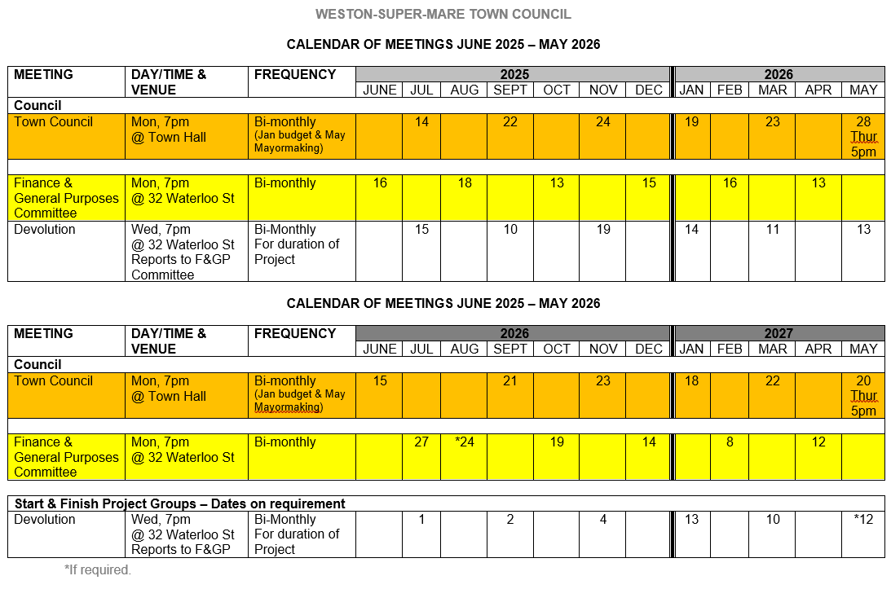

Appendix A1: Summary of the Devolution S&FG meetings and meeting outputs and recommendations

Devolution Start & Finish Group – Meeting Record and outputs
Meeting | Date | Outputs
1 | 20 March 2025 | Devolution programme initiation and early scoping
2 | 16 April 2025 | Development of devolution approach and priorities
3 | 18 June 2025 | Progression of devolution principles and programme considerations
4 | 2 September 2025 | Review of developing devolution framework and programme direction
5 | November 2025 | Meeting cancelled (Start of new Devolution Programme Manager contract)
6 | 14 January 2026 | Recommendation of Devolution Principles and key positions underpinning development of a WsMTC Devolution Framework

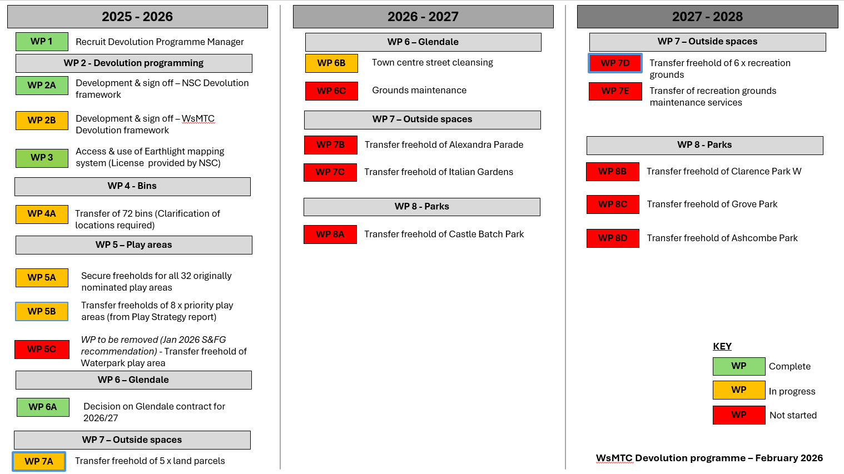

Appendix A2: Emerging WsMTC Devolution Programme of work

Appendix B: Devolution Principles variation log

Date | Summary of variation to a Devolution Principle
January 2026 | Principle – Freehold transfer as default  - Principle variation for the devolution of Play Areas:  Where freehold transfer is not immediately possible, interim arrangements such as a Memorandum of Understanding, Licence or Service Level Agreement, may be used only where essential, with a clear and agreed timetable for conversion to Freehold.  As recommended by the S&FG (January 2026) “It was agreed that Leases were not a suitable option for play area transfer, and that MOUs should be suggested in the interim with the view of working together with NSC to achieve Freehold transfers within a defined timeframe i.e. 18months.

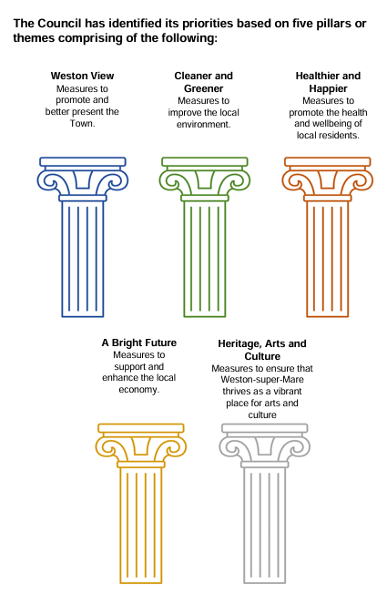
Appendix C: WsMTC Strategic Priorities 2020 – 2030 – The Five Pillars

- Weston View: Measures to promote and better present the Town. Our Aim To work with local community and partners to ensure that the town of Weston super-Mare has a positive image, with a vibrant town centre.
- Cleaner and Greener Measures to improve the local environment. Our Aim To work with local community and partners to ensure that the town and its wards become a cleaner and greener place to live and work protecting and enhancing the environment.
- Healthier and Happier Measures to promote the health and wellbeing of local residents. Our Aim To work with local community and partners to ensure that the town of Weston super-Mare and its wards prioritise its residents’ health and wellbeing.
- A Bright Future Measures to support and enhance the local economy. Our Aim To work with its own resources and with the local community and partners to ensure that the town of Weston-super-Mare and its wards has a bright long term future for its local economy
- Heritage, Arts and Culture Measures to ensure that Weston super Mare thrives as a vibrant place for arts and culture. Our Aim To work with local community and partners to ensure that the town of Weston super-Mare has growing opportunity for Culture, Heritage and the Arts.

Appendix D: Community Outcomes Framework

The Framework builds on earlier work developed through the Council’s Community Resilience Outcomes Framework (2022), which provides background context and explains the evolution of the outcomes-based approach now adopted by the Council.
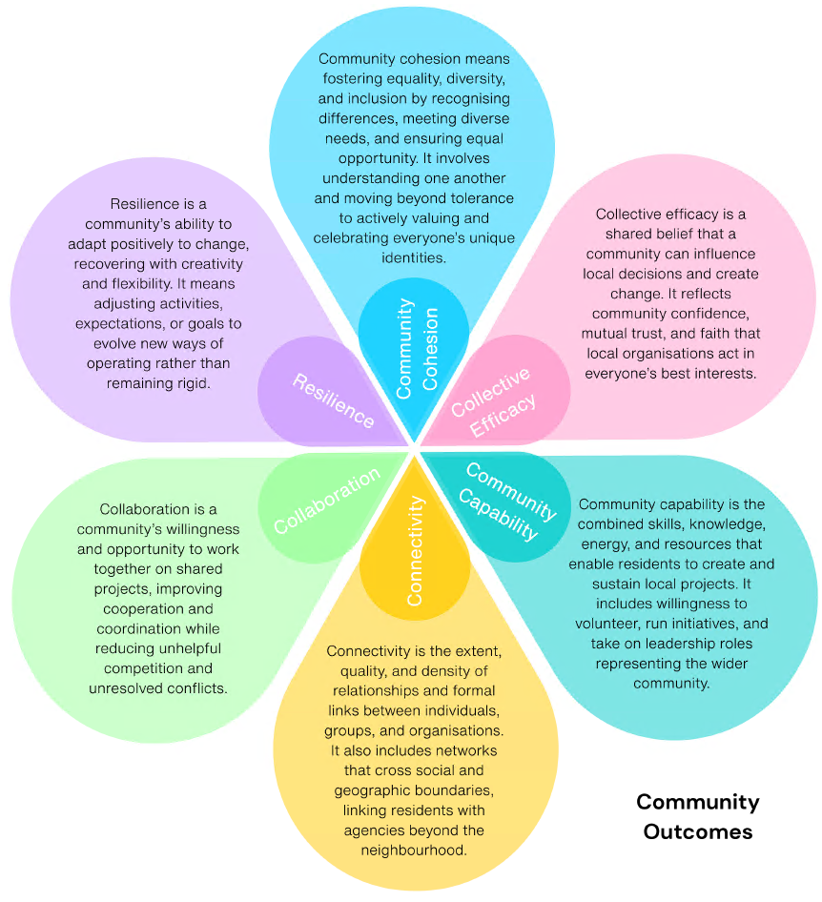
The Community Outcomes Framework does not operate as a separate decision framework. It is intended to inform and support the application of the Community Benefit Test alongside the Devolution Principles and other decision-making criteria within this Devolution Framework.

Appendix E: Key WsMTC policies to support assessment of suitability of Devolution proposals
The table below summarises the policies and formal council commitments most directly relevant to devolution decisions, showing how they support the checks and assessment considerations, and align with the Town Council’s five strategic pillars.
Proposal check category | Policy / Council Commitment | WsMTC Strategic Pillars - Most Relevant
Strategic check | WSMTC Strategy 2020–2030 | All five pillars
 | Community Outcomes Framework (Adopted commitment) | Healthier and Happier; Weston View; Heritage, Arts and Culture
 | Climate Commitment  (Adopted commitment) | Cleaner and Greener; A Bright Future
 | Environmental Policy | Cleaner and Greener; Weston View
 | Green Infrastructure Strategy | Cleaner and Greener; Weston View
Community Benefit check | Community Outcomes Framework (Adopted commitment) | Healthier and Happier; Weston View; Heritage, Arts and Culture
 | Equality & Diversity Policy | Healthier and Happier; Heritage, Arts and Culture
 | Safeguarding Policy | Healthier and Happier
 | Volunteer Policy | Healthier and Happier; Heritage, Arts and Culture; A Bright Future
Sustainability check | Climate Commitment  (Adopted commitment) | Cleaner and Greener; A Bright Future
 | Medium-Term Financial Plan (MTFP) | A Bright Future
 | Financial Regulations | A Bright Future; Weston View
 | Full Risk Register | A Bright Future; Weston View
 | Health & Safety Policy | Healthier and Happier; Weston View
 | Procurement Guide | A Bright Future
Risk & Governance check | Standing Orders | All five pillars
 | Committee Terms of Reference | All five pillars
 | Full Risk Register | A Bright Future; Weston View
 | Financial Regulations | A Bright Future; Weston View
 | Equality & Diversity Policy | Healthier and Happier; Heritage, Arts and Culture
 | Safeguarding Policy | Healthier and Happier
 | Health & Safety Policy | Healthier and Happier; Weston View
This table is intended as a practical reference rather than an exhaustive checklist. Councillors should apply judgement and proportionality, having regard to the nature, scale and risk of each proposed devolution opportunity.

REFERENCES
- North Somerset Council Local Devolution Programme: A Framework for Asset and Service Transfer in North Somerset – November 2025-Version 2
- Weston-super-Mare Town Council Strategy April 2020 – March 2030 (Reviewed and updated March 2025)
- Weston-super-Mare Town Council Policies
- Weston-super-Mare Town Council Community Outcomes Framework

Adopted by the Devolution Start & Finish Group on 11th March 2025
The Devolution Programme is a compilation of the agreed in principle assets for transfer as well as potential assets for transfer as agreed by the Devolution S&FG. This is to enable development of a work programme to support the planning of the required resource and/ or capacity and associated timelines require to deliver the Devolution programme for WsMTC.
Noted in Agenda Item 6.1 of Jan. 2026 S&FG: The council’s default position for the devolution programme is that the transfer of assets should, wherever possible, be on a freehold basis. This reflects the importance of long-term stewardship, clarity of responsibility and sustainability. It is not a standalone council policy and does not preclude alternative arrangements where justified by specific circumstances and approved through the appropriate governance process.
Future Principle variations may be added to this framework following consideration and recommendation by the Devolution Start & Finish Group, and approval through the appropriate committee process.

